SQL Joins
Note: Create the following dummy tables in MySQL Workbench using CREATE FUNCTION
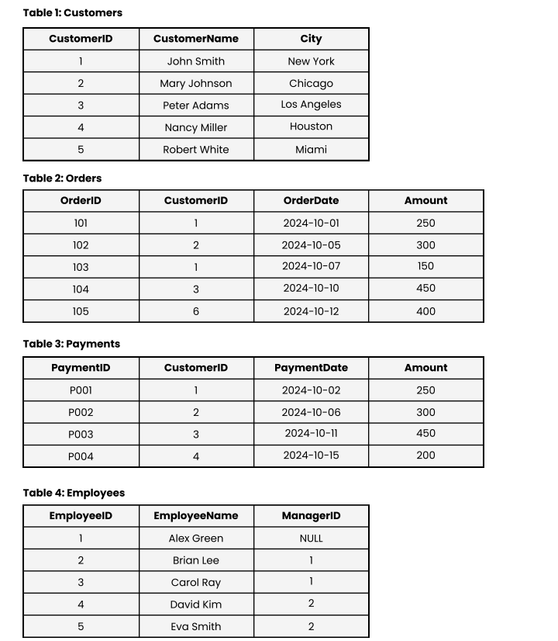

- CREATE DATABASE CompanyDB;
use CompanyDB;
- CREATE TABLE Customers (
CustomerID INT PRIMARY KEY,
CustomerName VARCHAR(100),
City VARCHAR(100));
- INSERT INTO Customers (CustomerID, CustomerName, City) VALUES
(1, 'John Smith', 'New York'),
(2, 'Mary Johnson', 'Chicago'),
(3, 'Peter Adams', 'Los Angeles'),
(4, 'Nancy Miller', 'Houston'),
(5, 'Robert White', 'Miami');
- select * from customers;
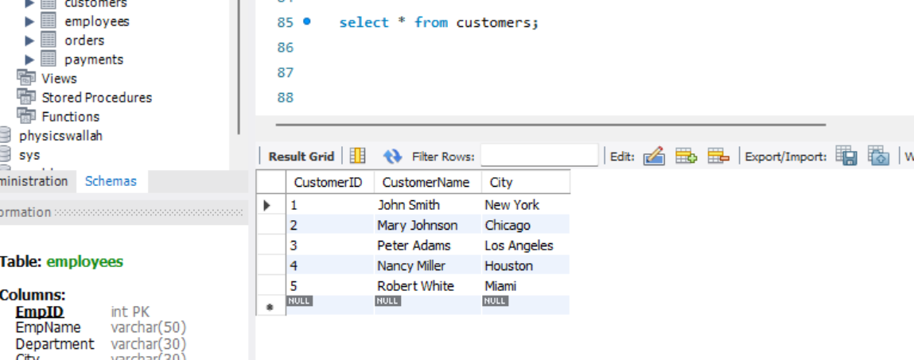

- CREATE TABLE Orders (
OrderID INT PRIMARY KEY,
CustomerID INT,
OrderDate DATE,
Amount DECIMAL(10,2));
- SET FOREIGN_KEY_CHECKS = 0;
- select * from orders;
- INSERT INTO Orders (OrderID, CustomerID, OrderDate, Amount) VALUES
(101, 1, '2024-10-01', 250),
(102, 2, '2024-10-05', 300),
(103, 1, '2024-10-07', 150),
(104, 3, '2024-10-10', 450),
(105, 6, '2024-10-12', 400);
- select * from orders;

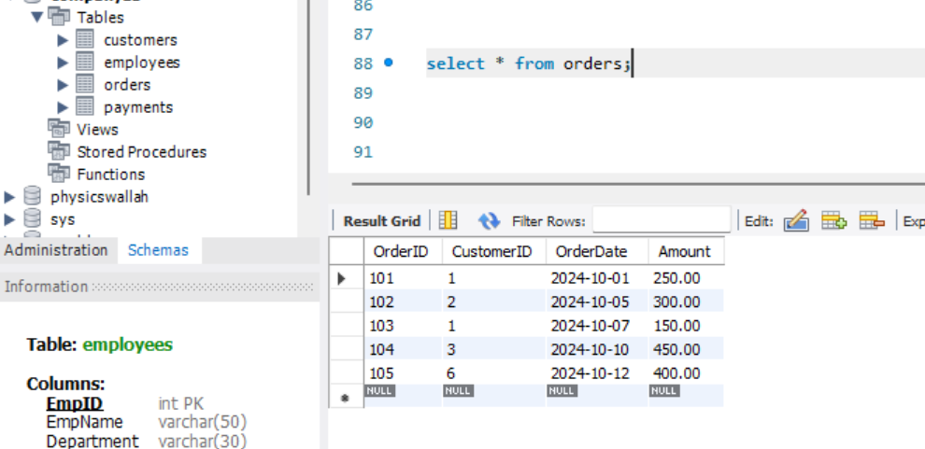

- CREATE TABLE Payments (
PaymentID VARCHAR(10) PRIMARY KEY,
CustomerID INT,
PaymentDate DATE,
Amount DECIMAL(10,2),
FOREIGN KEY (CustomerID) REFERENCES Customers(CustomerID));
- INSERT INTO Payments VALUES
('P001', 1, '2024-10-02', 250),
('P002', 2, '2024-10-06', 300),
('P003', 3, '2024-10-11', 450),
('P004', 4, '2024-10-15', 200);
- select * from payments;
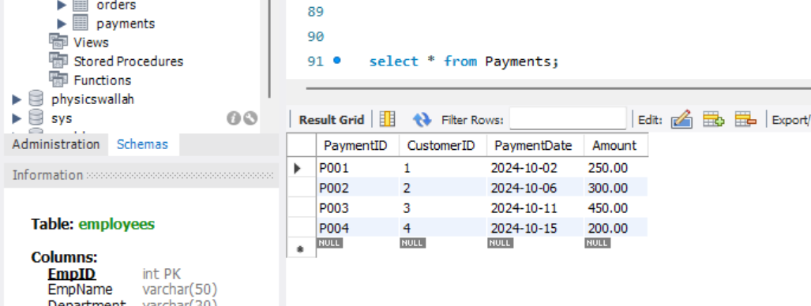

- CREATE TABLE Employees (
EmployeeID INT PRIMARY KEY,
EmployeeName VARCHAR(100),
ManagerID INT,
FOREIGN KEY (ManagerID) REFERENCES Employees(EmployeeID));
- INSERT INTO Employees VALUES
(1, 'Alex Green', NULL),
(2, 'Brian Lee', 1),
(3, 'Carol Ray', 1),
(4, 'David Kim', 2),
(5, 'Eva Smith', 2);
- select * from employees;
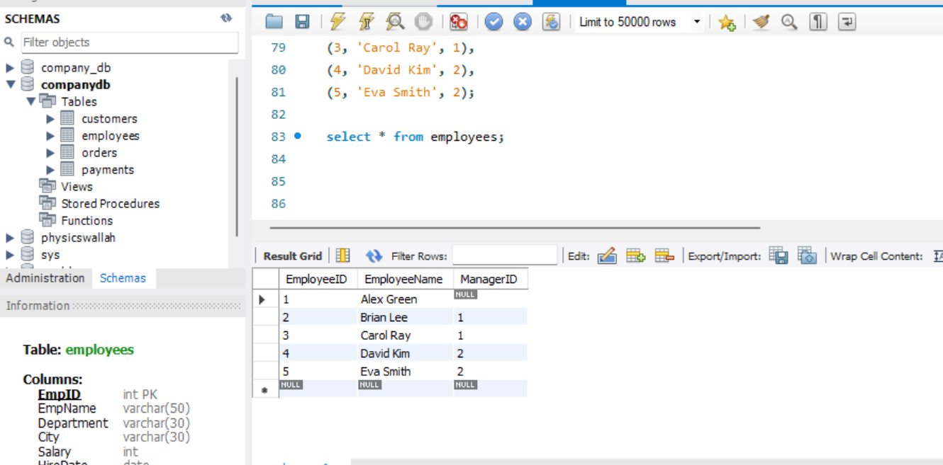

- Retrieve all customers who have placed at least one order.
- SELECT DISTINCT c.CustomerID, c.CustomerName, c.City
FROM Customers c
INNER JOIN Orders o
ON c.CustomerID = o.CustomerID;
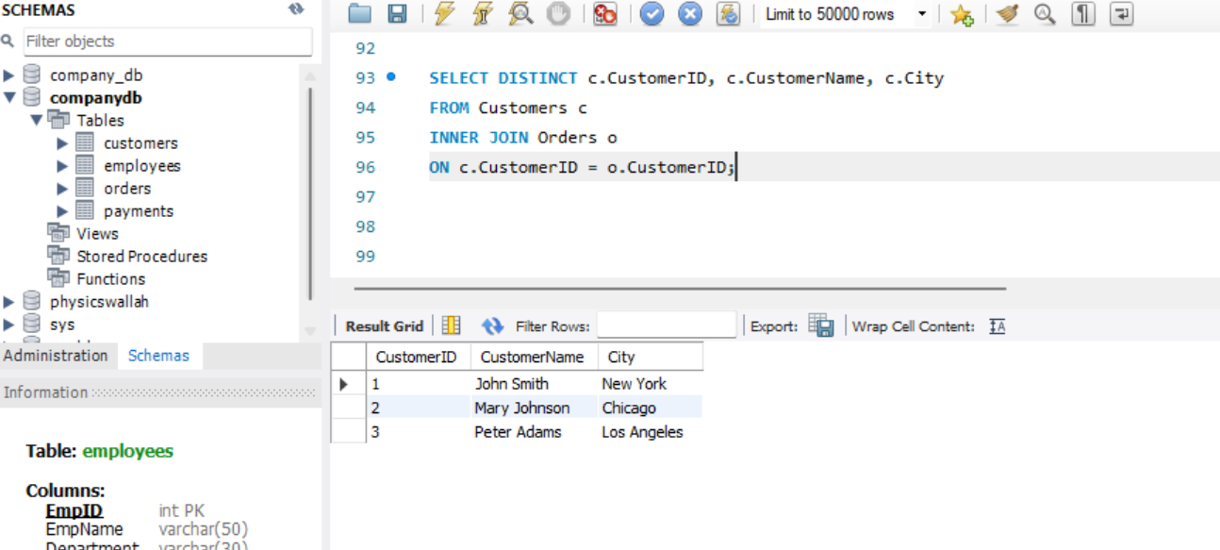

- Retrieve all customers and their orders, including customers who have not placed any orders.
- SELECT
c.CustomerID,
c.CustomerName,
c.City,
o.OrderID,
o.OrderDate,
o.Amount
FROM Customers c
LEFT JOIN Orders o
ON c.CustomerID = o.CustomerID;

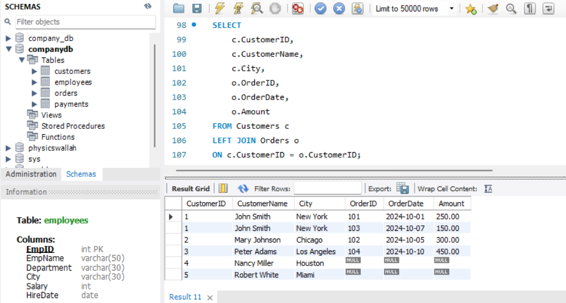

- Retrieve all orders and their corresponding customers, including orders placed by unknown customers.
- SELECT
o.OrderID,
o.CustomerID,
c.CustomerName,
c.City,
o.OrderDate,
o.Amount
FROM Orders o
LEFT JOIN Customers c
ON o.CustomerID = c.CustomerID;

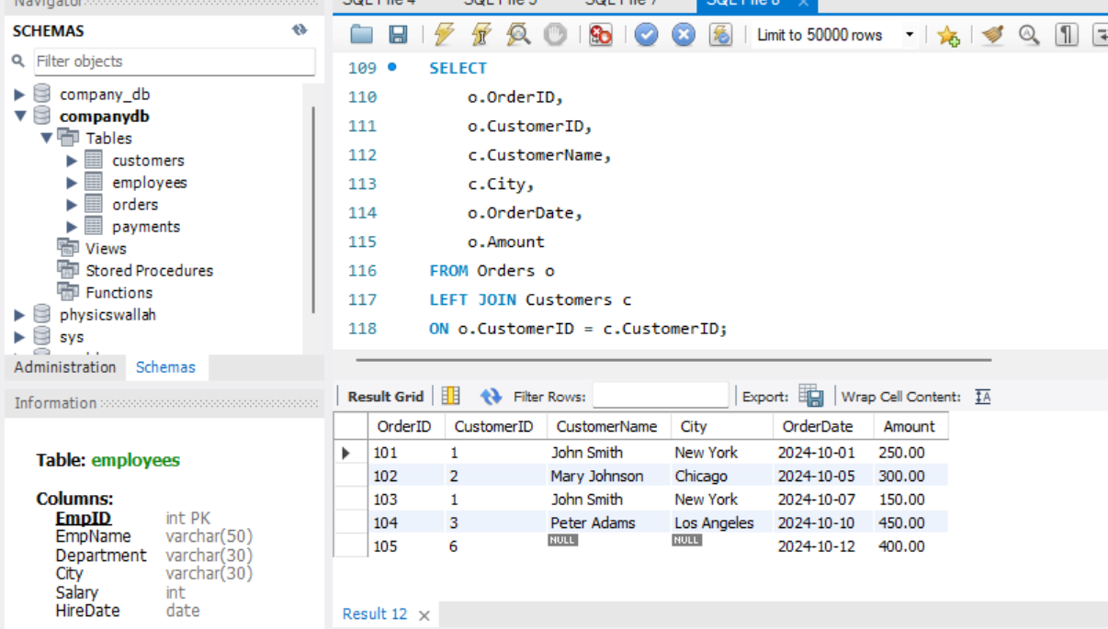

- Display all customers and orders, whether matched or not.
- SELECT
c.CustomerID,
c.CustomerName,
c.City,
o.OrderID,
o.OrderDate,
o.Amount
FROM Customers c
LEFT JOIN Orders o
ON c.CustomerID = o.CustomerID
UNION
SELECT
c.CustomerID,
c.CustomerName,
c.City,
o.OrderID,
o.OrderDate,
o.Amount
FROM Customers c
RIGHT JOIN Orders o
ON c.CustomerID = o.CustomerID;

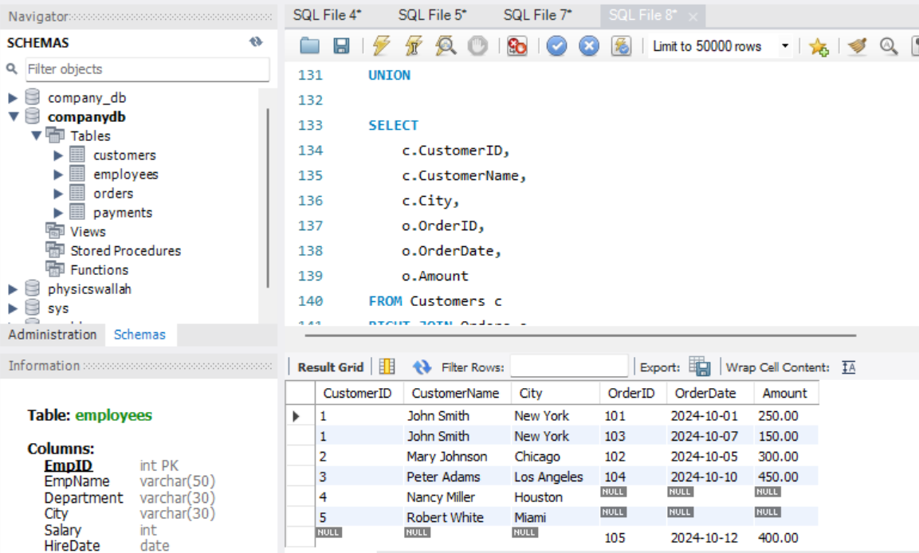

- Find customers who have not placed any orders
- SELECT
c.CustomerID,
c.CustomerName,
c.City
FROM Customers c
LEFT JOIN Orders o
ON c.CustomerID = o.CustomerID
WHERE o.OrderID IS NULL;

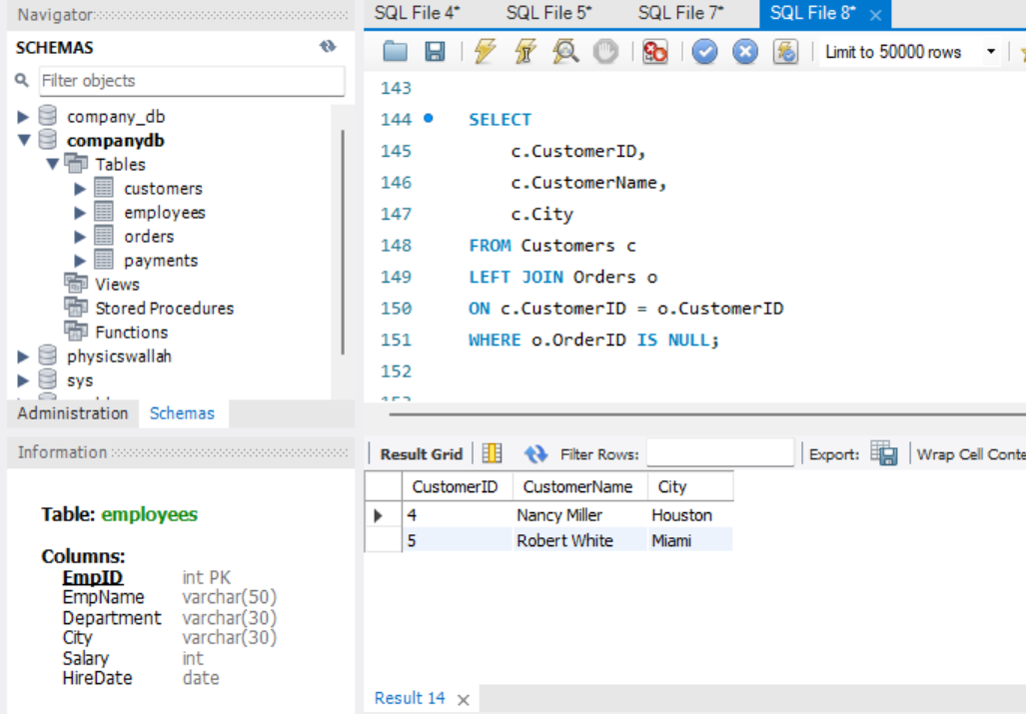

- Retrieve customers who made payments but did not place any orders.
- SELECT DISTINCT
c.CustomerID,
c.CustomerName,
c.City
FROM Customers c
INNER JOIN Payments p
ON c.CustomerID = p.CustomerID
LEFT JOIN Orders o
ON c.CustomerID = o.CustomerID
WHERE o.OrderID IS NULL;

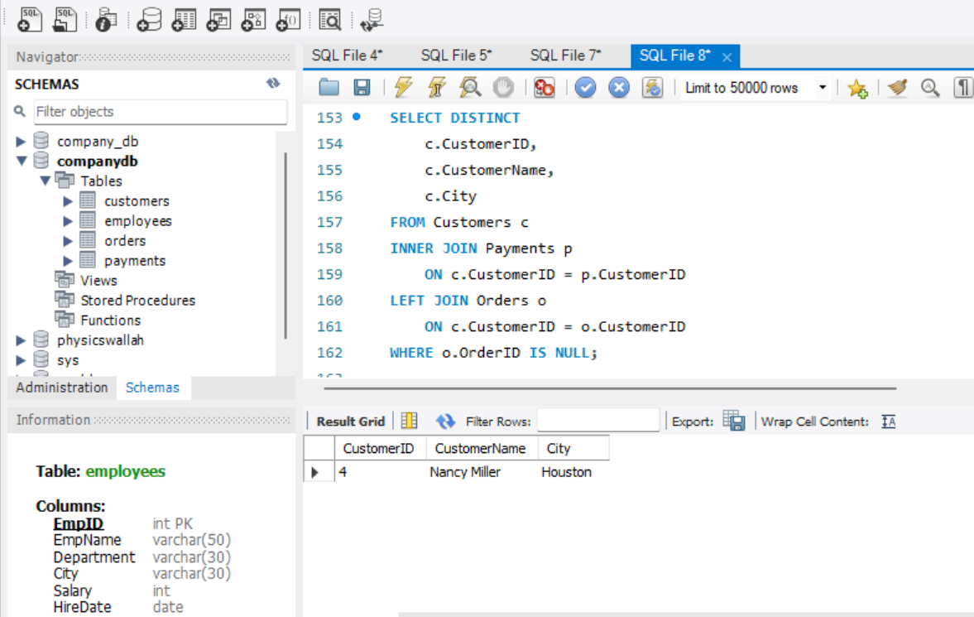

- Generate a list of all possible combinations between Customers and Orders
- SELECT
c.CustomerID,
c.CustomerName,
o.OrderID,
o.OrderDate,
o.Amount
FROM Customers c
CROSS JOIN Orders o;

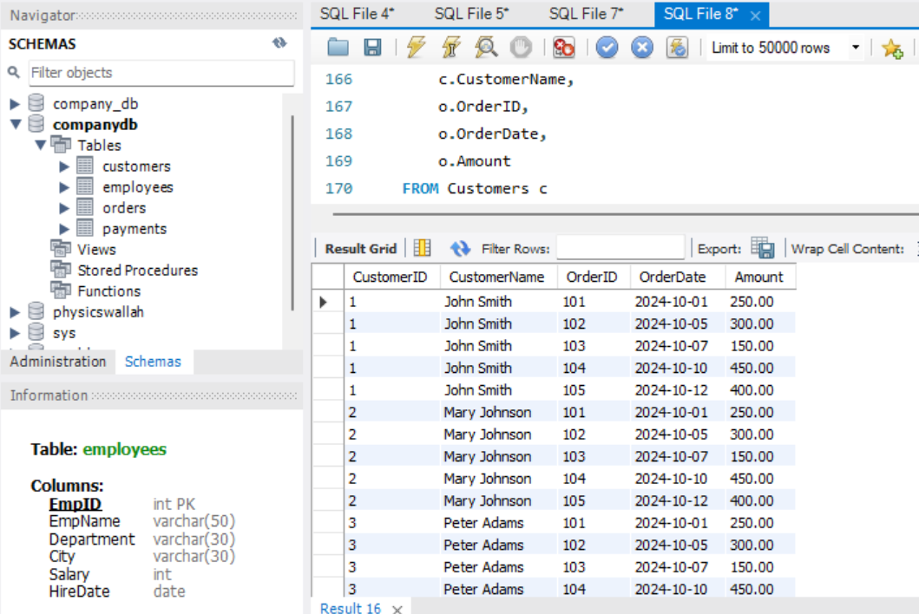
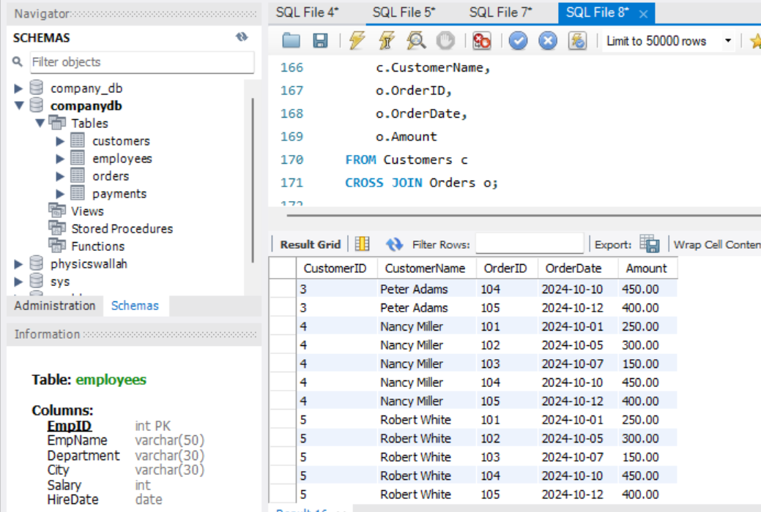

- Show all customers along with order and payment amounts in one table.
- SELECT
c.CustomerID,
c.CustomerName,
c.City,
COALESCE(SUM(o.Amount), 0) AS TotalOrderAmount,
COALESCE(SUM(p.Amount), 0) AS TotalPaymentAmount
FROM Customers c
LEFT JOIN Orders o
ON c.CustomerID = o.CustomerID
LEFT JOIN Payments p
ON c.CustomerID = p.CustomerID
GROUP BY c.CustomerID, c.CustomerName, c.City;

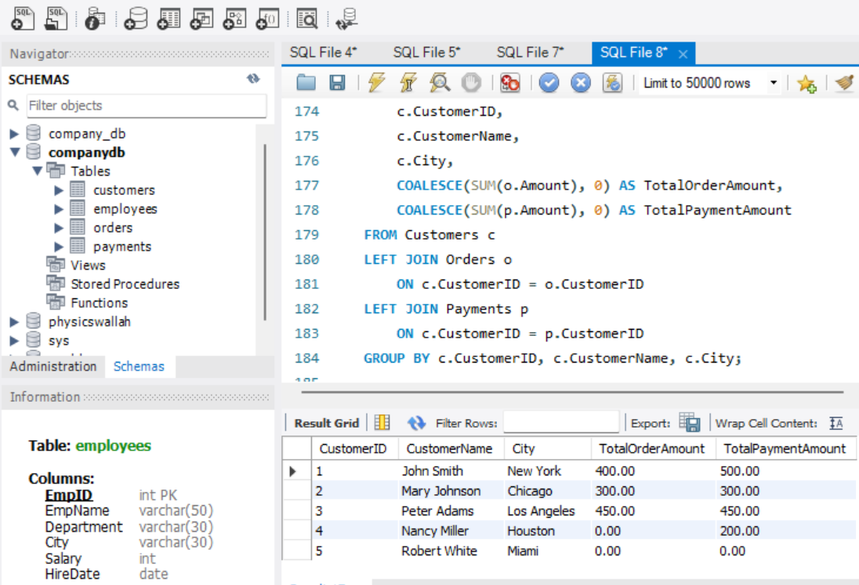

- Retrieve all customers who have both placed orders and made payments.
- SELECT DISTINCT
c.CustomerID,
c.CustomerName,
c.City
FROM Customers c
INNER JOIN Orders o
ON c.CustomerID = o.CustomerID
INNER JOIN Payments p
ON c.CustomerID = p.CustomerID;

